Centroid Quiz
Find the centroid (x̄, ȳ) of the shape shown.
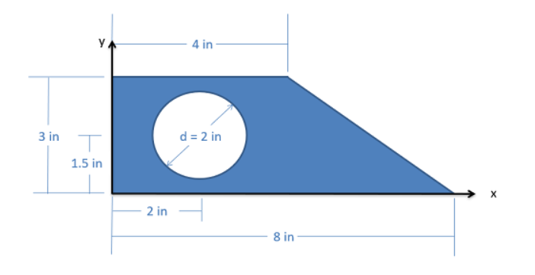

Step 1: Break into Shapes (name them below)

1. _______________________________
2. _______________________________
3. _______________________________

Step 2: Fill Table
Shape Area x y A·x A·y
1 __________ __________ __________ __________ __________
2 __________ __________ __________ __________ __________
3 __________ __________ __________ __________ __________
Total ΣA= ______________
ΣAx= _______________________ ΣAy= ________________________

Step 3: Compute
x̄ = Σ(Ax)/ΣA
ȳ = Σ(Ay)/ΣA

(x̄, ȳ) = (_____, _____)

Centroid Answer Key – Composite Shape with Hole

Step 1: Identify Shapes
1. Rectangle (positive)
2. Triangle (positive)
3. Circular hole (negative)

Step 2: Areas
Rectangle: A₁ = 4 × 3 = 12 in²
Triangle: A₂ = ½(4)(3) = 6 in²
Circle (hole): A₃ = -π(1²) = -π ≈ -3.14 in²

Step 3: Centroid Locations
Rectangle: (x₁, y₁) = (2, 1.5)
Triangle: (x₂, y₂) = (5.33, 1)
Circle: (x₃, y₃) = (2, 1.5)

Step 4: Compute A·x and A·y
Rectangle: A₁x₁ = 24, A₁y₁ = 18
Triangle: A₂x₂ = 32, A₂y₂ = 6
Circle: A₃x₃ = -6.28, A₃y₃ = -4.71

Step 5: Summations
ΣA = 12 + 6 - π ≈ 14.86
Σ(Ax) = 24 + 32 - 6.28 = 49.72
Σ(Ay) = 18 + 6 - 4.71 = 19.29

Step 6: Final Centroid
x̄ = Σ(Ax) / ΣA = 49.72 / 14.86 ≈ 3.35 in
ȳ = Σ(Ay) / ΣA = 19.29 / 14.86 ≈ 1.30 in

Final Answer
(x̄, ȳ) = (3.35 in, 1.30 in)

